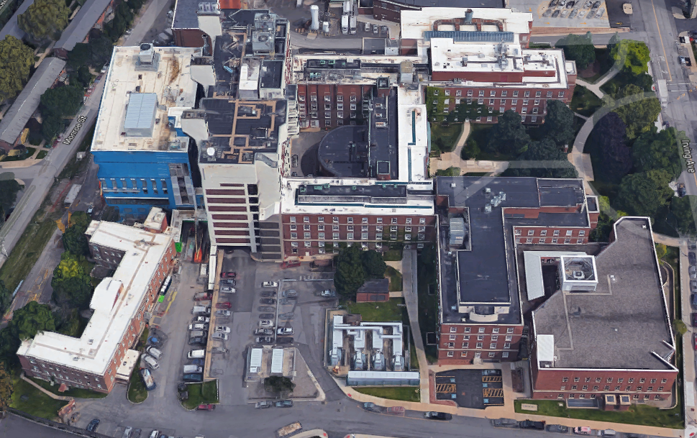

The New Academic Building (Old Map) - – Limited Access (M-F 6am-6pm)

The B3 Courtyard door – Locked and Secured

Silverman Hall - The front and back doors – Locked and Secured

B3 Courtyard Loading Bay Door – Limited Access (M-F 6am-6pm)

South Main Door into Weiskotten Hall – Limited Access (6am-6pm)

Back door into the Health Sciences Library – Locked and Secured

Back door into Weiskotten Hall – Locked and Secured

Weiskotten Hall Courtyard Doors (3) – Locked and Secured

Setnor main entrance and Memorial Drive entrance – Locked and Secured